Chapter 6, Solution 3.

Design a problem to help other students to better understand how capacitors work.

Although there are many ways to work this problem, this is an example based on the same kind of problem asked in the third edition.

Problem

In 5 s, the voltage across a 40-mF capacitor changes from 160 V to
220 V. Calculate the average current through the capacitor.

Solution

i = C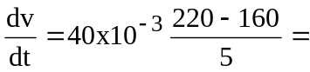 480 mA

